*HARSH KASHYAP  
CSE 4*

*101917088*

[*hkashyap_be19@thapar.edu*](mailto:hkashyap_be19@thapar.edu)

**PRACTICAL COMPUTING**



Submitted to

Aashima Sharma

**__________________________________________**

**Assignment 1**

**Question 1**

**A) List out all the files present in the system (including hidden ones)**

**B) list all the files with their size**

**C) sort all the listed files with time and date.**

**Solution - a) ls -a**



**b) ls -al in long format**

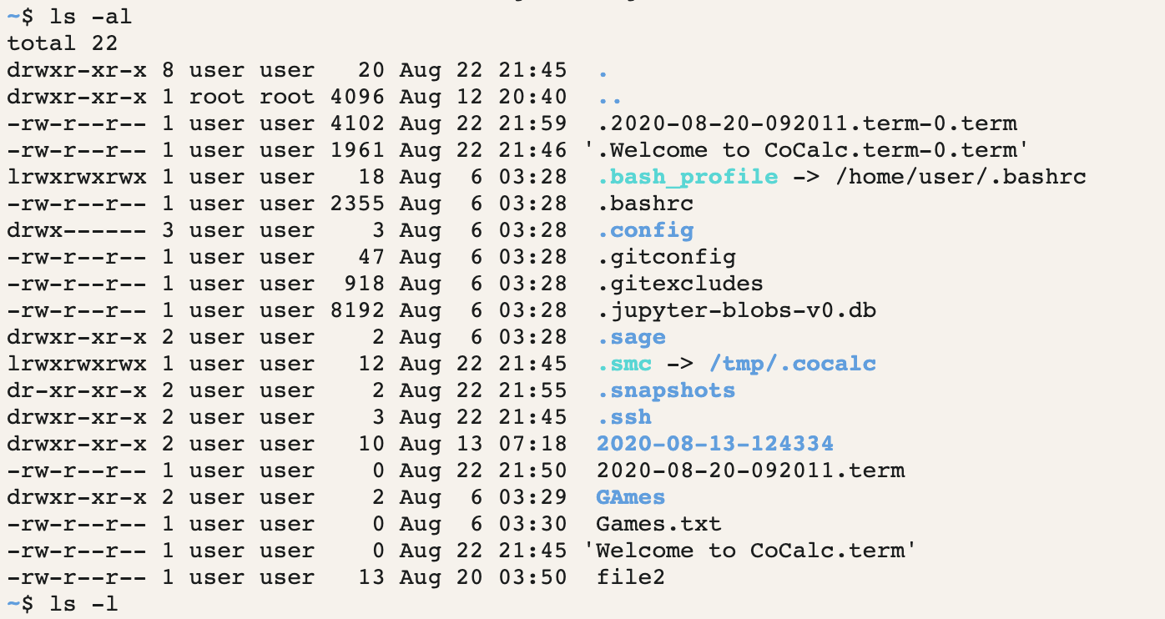

**c) ls -alt**

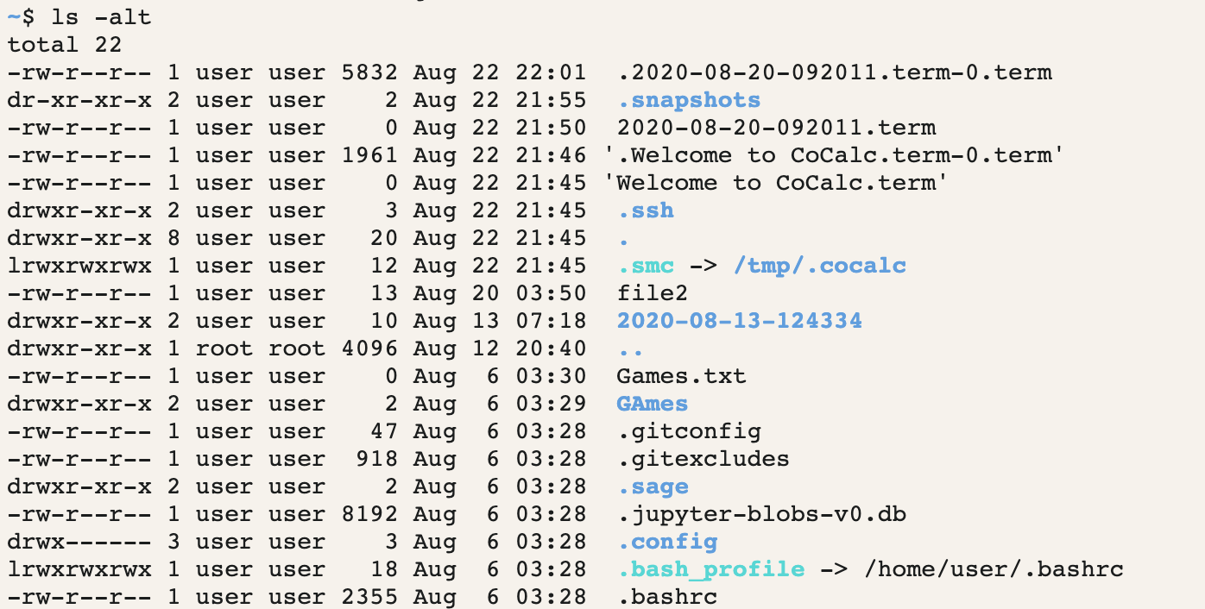

**__________________________________________**

**Question 2**

**We have a file sample.txt.**

**A) How can we use this redirection operator as “>”?**

**B) Also, the other redirection operator as “>>”**

**Solution**

**The “>” operator is used to write on a file and if certain contents are already present it will automatically overwrite the contents of the file.**

**Whereas, the “>>” operator is used to append contents to the existing file.**

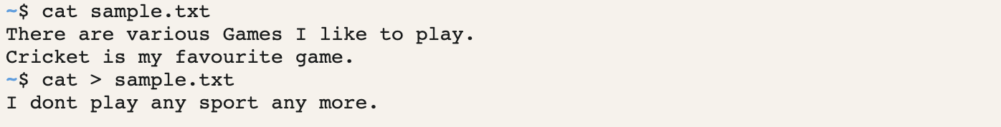

**__________________________________________**

**Question 3**

**How to copy a file in Linux?**

**Solution**

**To copy a file in Linux, we use cp command.**

**Syntax -** cp SourceFile TargetFile

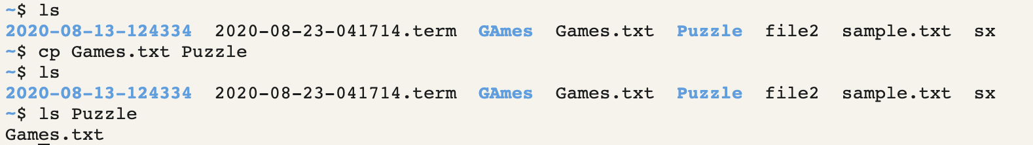

**__________________________________________**

**Question 4**

**How would you delete a directory in Linux? Execute both the commands.**

**Solution - rmdir**

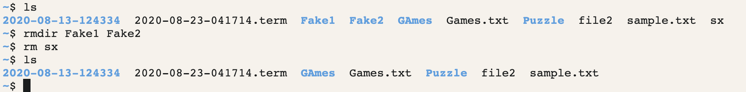

**__________________________________________**

**Question 5**

**How does the case sensitivity affects the way you use commands?**

**Solution - Linux is case sensitive. The commands that are running in lowercase won’t run in uppercase.**

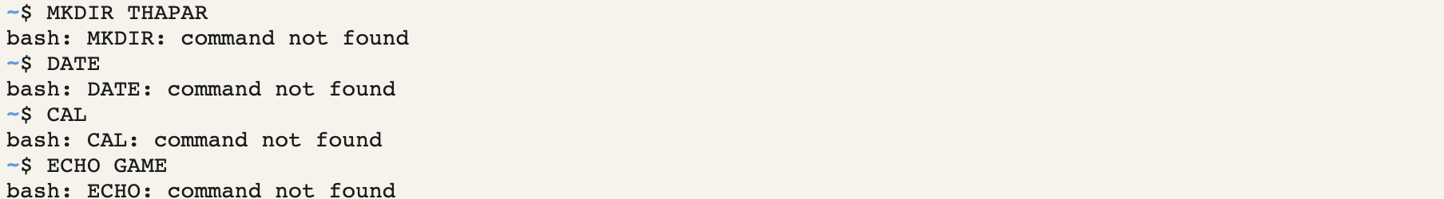

**__________________________________________**

**Question 6**

**A) How can we switch from present directory to any other directory?**

**B) Create one directory with the name practical computing.**

**C) Create a file in practical computing directory with the name as commands.txt.**

**D) Write the basic commands in that particular file**

**E) Copy the content of commands.txt to linuxcommands.txt**

**F) Check if the contents have been written on the new file**

**G) Remove the previous file i.e. commands.txt from the directory itself**

**Solution -**

**A) To switch from parent to any other directory, use command cd followed by the directory you want to switch.**

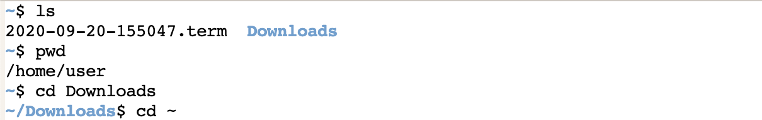

**The next commands for all the operation in question are as follows :**



